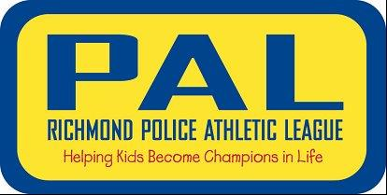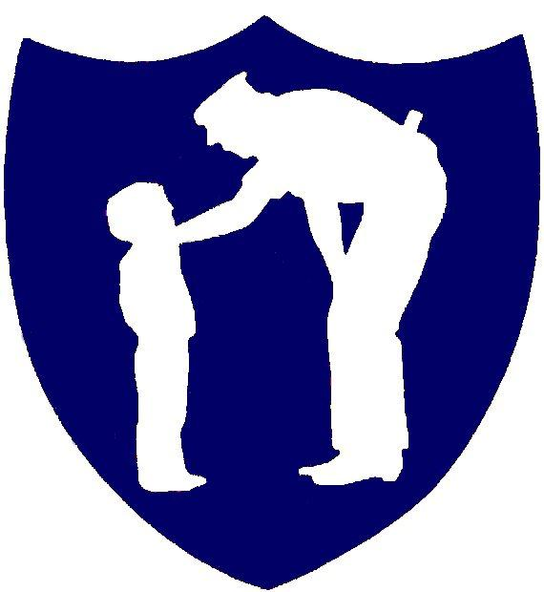

On Monday, May 15, 2023 at Stonehenge Country Club come join Chief Rick Edwards and the Richmond Police Athletic League (PAL) for its annual fundraiser.

PAL is a non-profit organization that reaches out to inner city youth through sports programs that seek to build positive relationships between police officers and the kids they serve.Join us as a sponsor or put together a team.

**www.richmondpal.com**

**804-646-1832**

All golfers will receive a gift bag with PAL signature gifts and other giveaways. Lunch, dinner and beverages included with fee.

For more information about sponsorship opportunities, please contact me at:

Perry.Barber@richmondgov.com

When: May 15, 2023

Where: 1000 Farnham Drive

Midlothian, VA 23236

Time: 8:30 am - Registration

10:00 – Shotgun Start

**Here are the ways you can support us:**

* **Golf Team - $550 (four players)**
* **Hole Sponsor - $600**
* **Lieutenant level - $1,200**
* **Captain Level - $2,500**

Come Join the Challenge!!

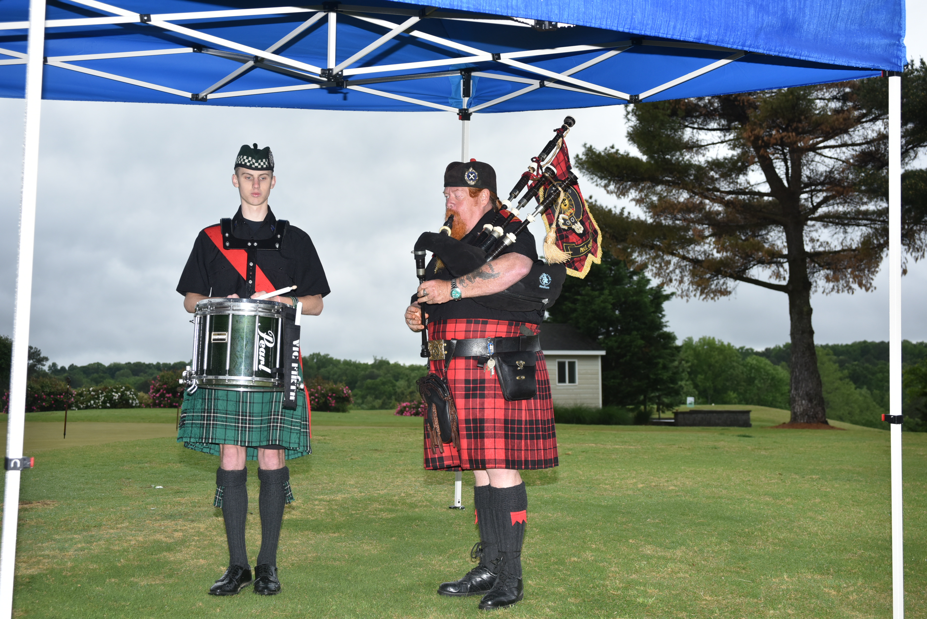

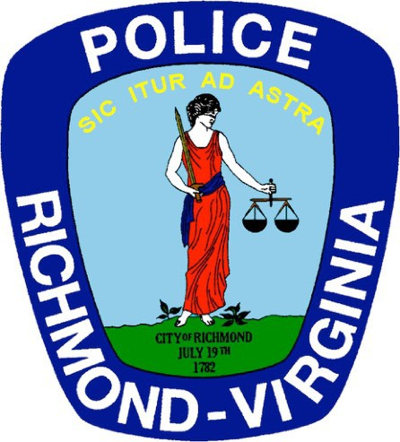

2023 Chiefs Challenge Benefiting Richmond PAL