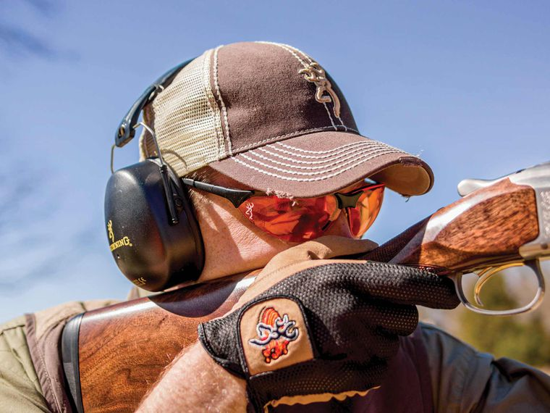

2023 PULL FOR PAL
September 18, 2023
Old Forge Sporting’s Clay
Providence Forge Va.
Registration begins at 9 a.m.
Shotgun start at 10 a.m.
Breakfast and lunch will be served.
Tons of raffle gifts.
Come join the fun!

